**Master Functional Document**

|  |  |
| --- | --- |
| **Application** | NGERP - Centra |
| **Service Bundle** | Master Management |
| **Service Request** | Attribute Set |

**Description:**

Attribute Set in Compiere (NGERP - Centra) defines additional attributes for products such as Serial Number, Lot Number, and Guarantee Date. It enables tracking of product instances and their attributes. Shelf Life determines the expiration period, and Guarantee Days set the post-sale customer service date. If Mandatory, an instance must be created before shipping.

**Workflow Process:**

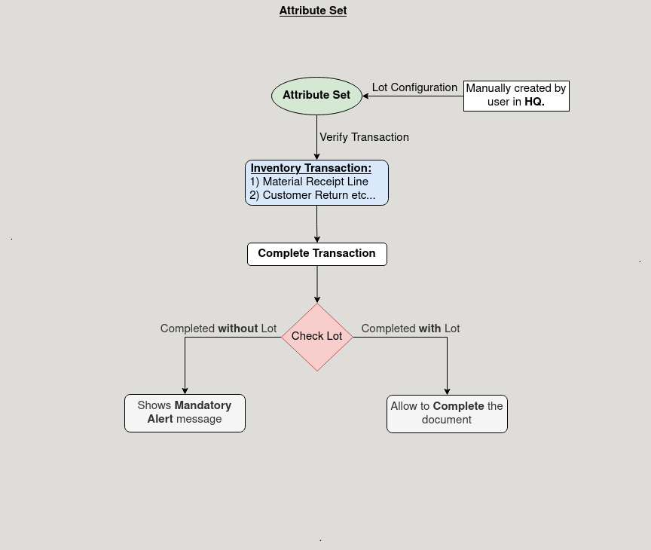

**Business Rules:**

* It is visible in both **HQ** and **ROW.**
* **Creation** is possible only in **HQ.**
* Active status must be set for the Attribute Set to be used in product creation.
* Shelf Life is 0 means no expiry date is calculated.
* If Mandatory Serial No is selected, a Serial Number must be entered.
* Lot Control requires a Lot Number if Mandatory Lot is enabled.
* Expiration Date must be entered if marked Mandatory for product instances.